Jackson Warren

Jeremy Bergen

CSCI 370

11/11/21

Week 6 Lab

Section 1:

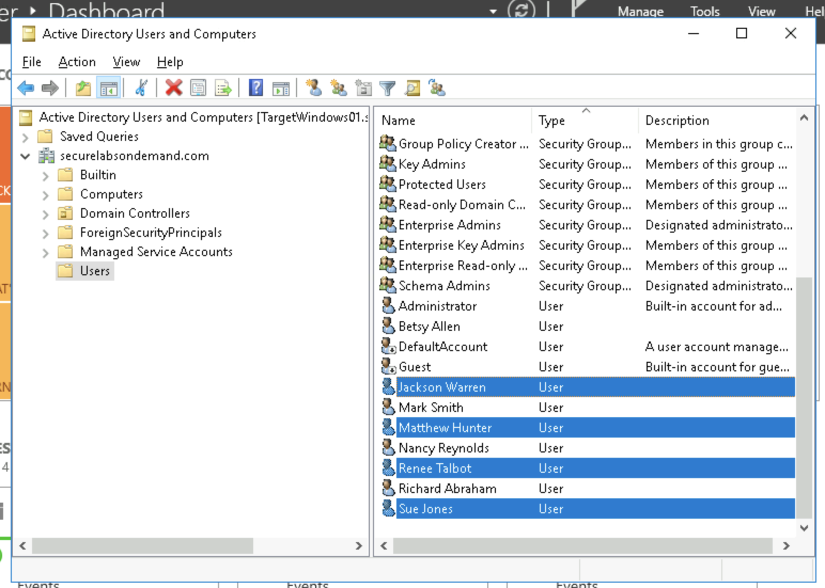

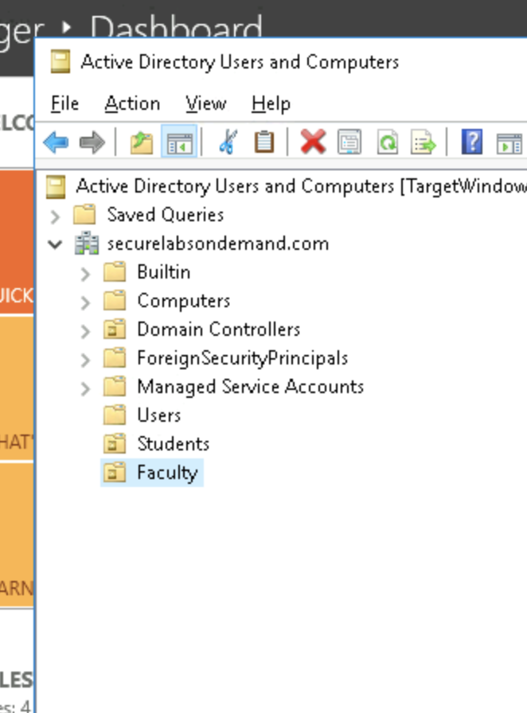

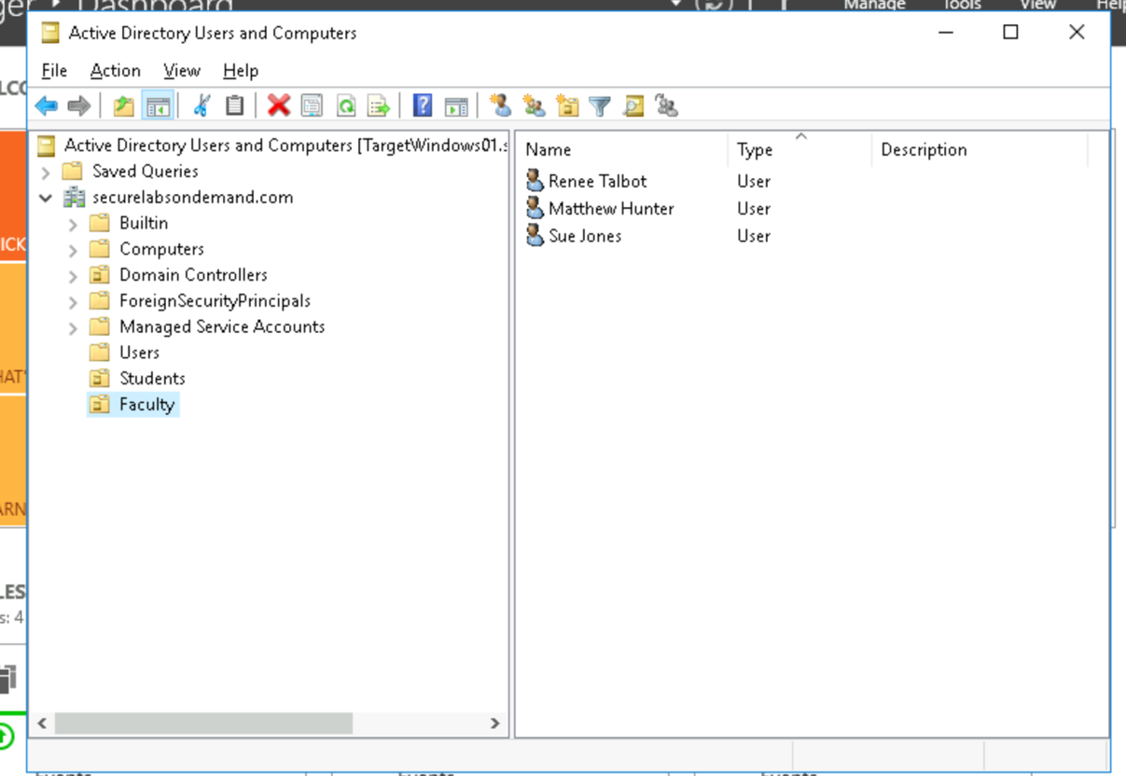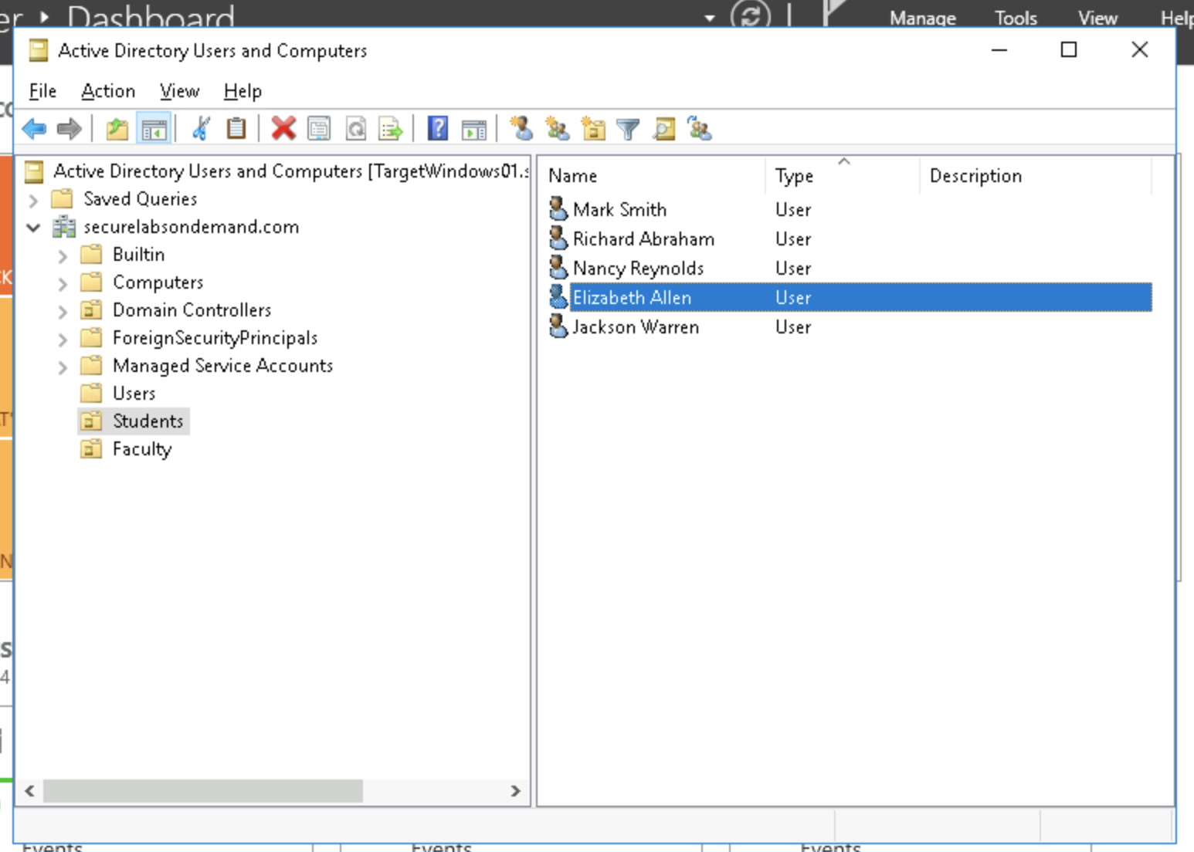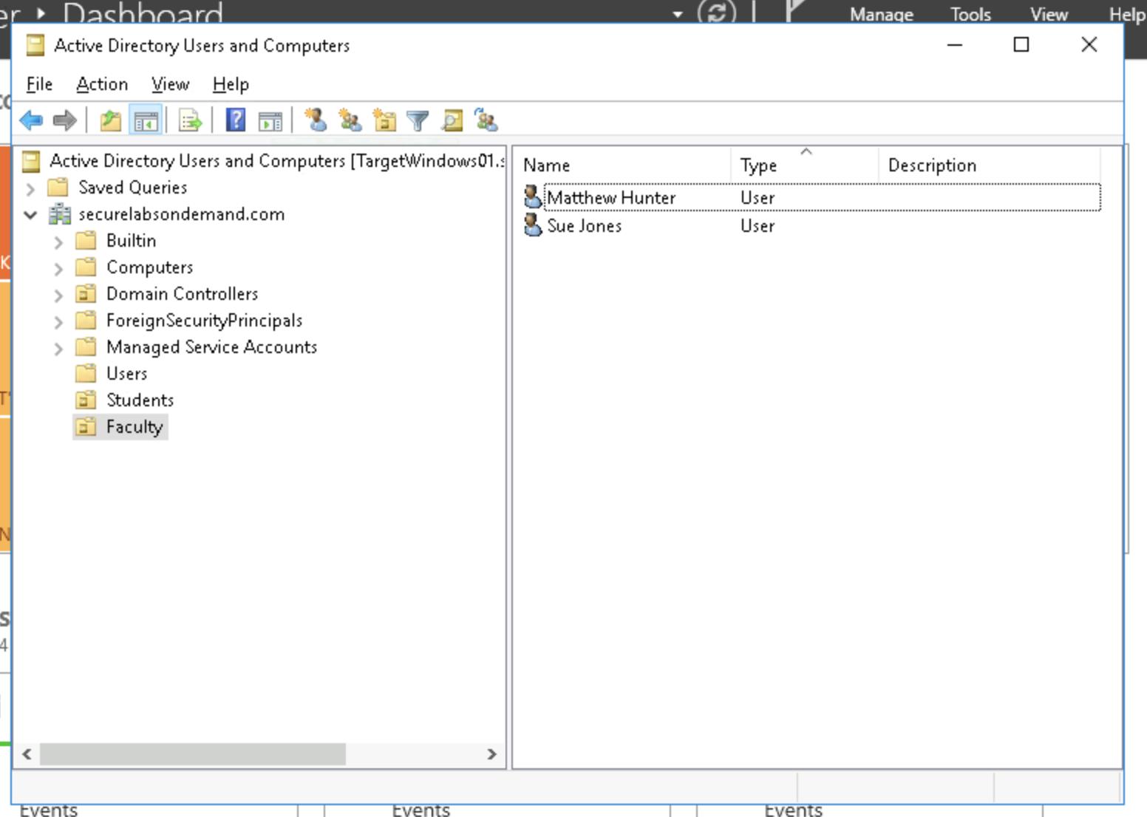

Section 2:

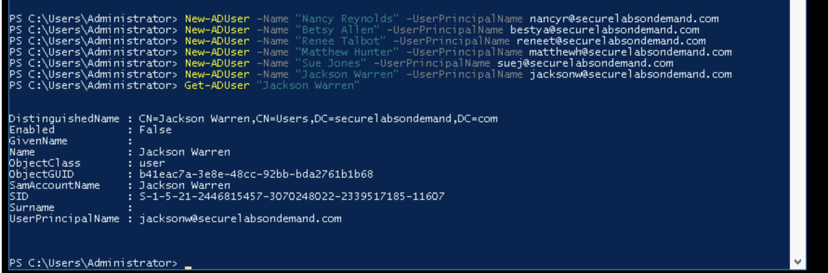

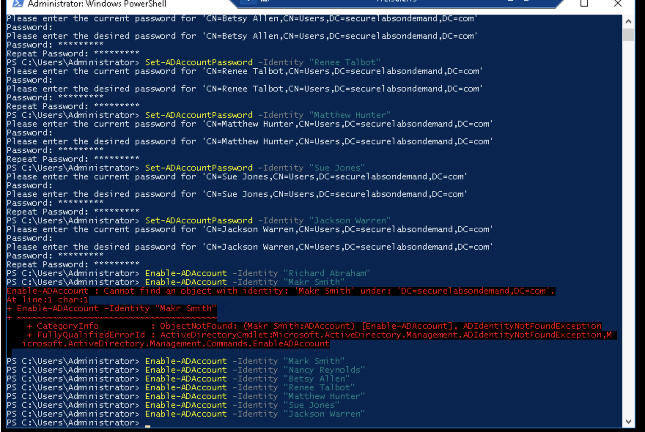

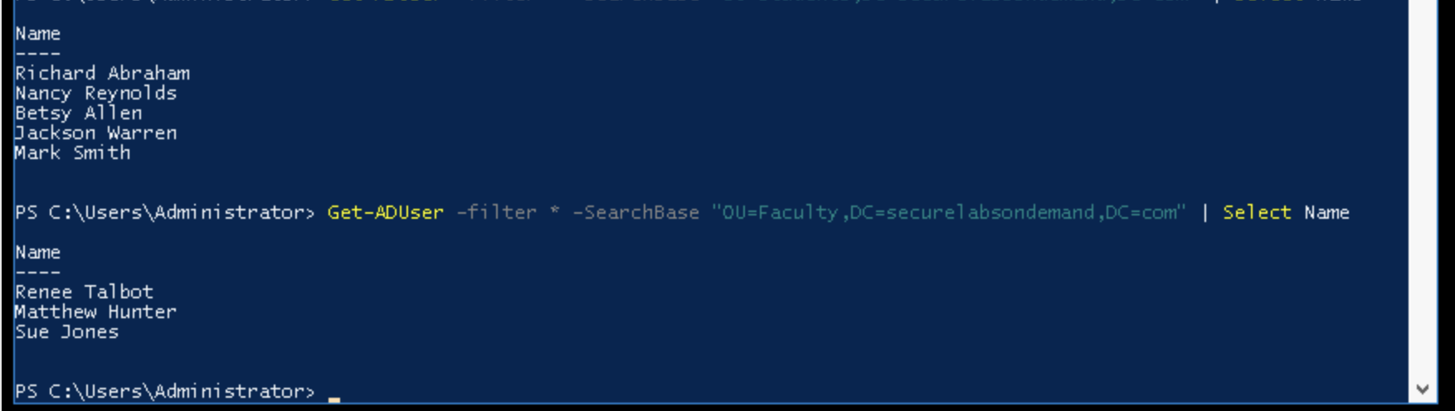

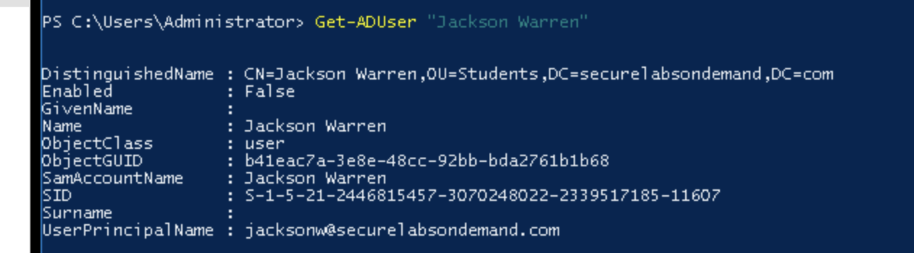

Section 3:

Part 1:

Quite frankly, I would almost always use the GUI to do this. It was made for a reason and makes creating and editing accounts easier. Not to mention, knowing these commands by heart is a little bit much for just editing user permissions in my opinion. The interface makes things faster and easier.

Part 2: 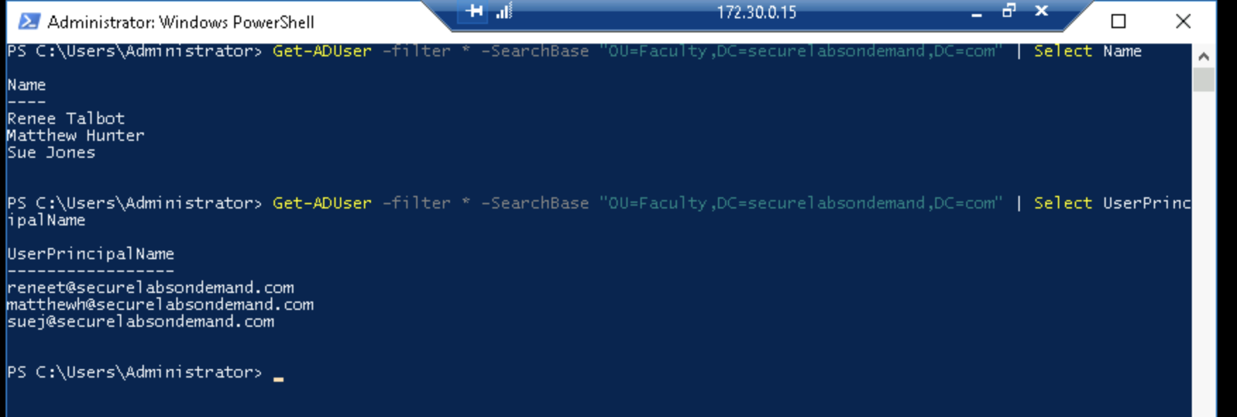

I couldn’t figure out how to list the group the user was in, but obviously by filtering based off group we can tell we are looking at the faculty members.

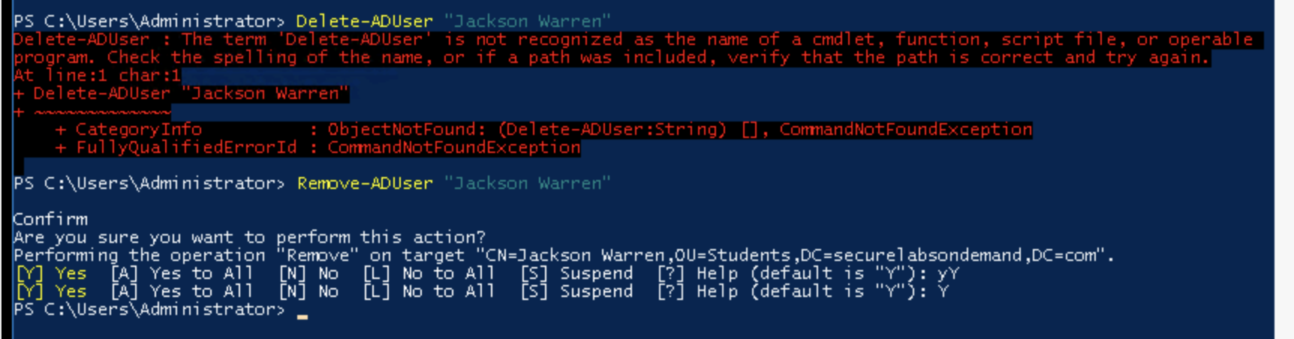

Part 3:

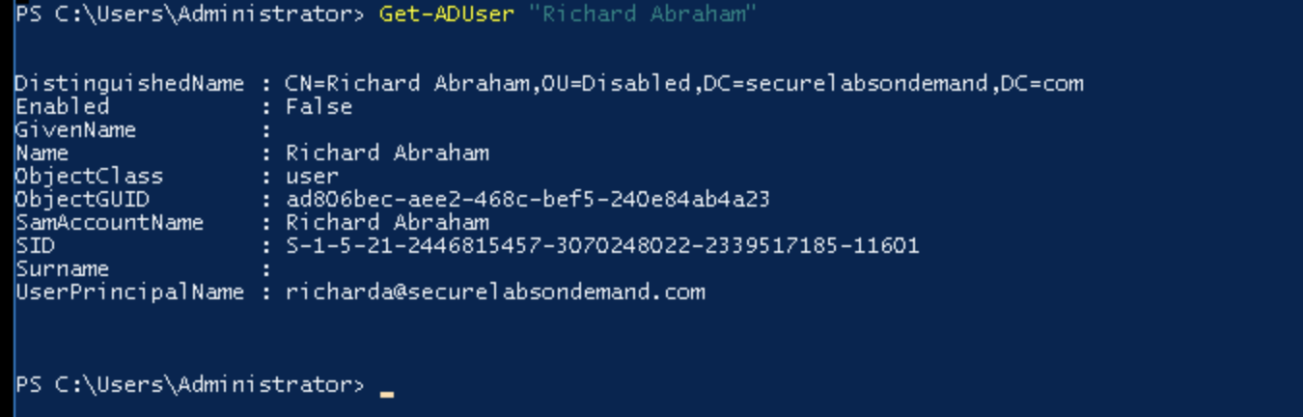

Here, I moved Richard Abraham into group “Disabled”. I deleted myself during the last step, so I could not move myself into the group since I was the other disabled one.